Mid Holderness Ward – February 2020

- Crime and ASB

Detailed crime and ASB data for your area can be obtained by visiting www.police.uk and following the ‘Find your Neighbourhood’ link.

- What’s Happening in Your Area & Community Priorities

12 crimes reported during January 2020, improved decrease from 16 recorded in December 2019;

- Residential Burglary reports – pleased to report that there was no burglaries in dwellings across the ward area in January
- Garage Burglary reports – pleased to report that there was no burglaries to shed or domestic garages. A Porta cabin on a farm near Old Ellerby was broken into during the night of the 12th/13th but nothing was stolen.

To keep your home:

- Use timer switches on lights to make it look as if your home is occupied.

- Ensure all doors and windows are secure when you leave and when you go to bed.

- If possible use security lighting at the front and back of your property.

- Make sure all garden tools and ladders are locked away when not being used.

- Use a good quality lock on any garden sheds and outhouses.

- Make a note of all makes, models and serial numbers of expensive items in your home.

- Create a FREE and secure inventory of all your personal property at www.immobilise.com

- If you notice anything suspicious in your neighbourhood report it on 101.

- Thefts – two thefts reported, 13th January Electric fence energiser stolen from a field near to Main Street, Swine. A make off without paying for fuel on Main Road, Bilton.
- Damage – four reports. Between 3rd and 15th January a security light with WiFi unit damaged. 20th January -a vehicle parked on England Road, Bilton had damaged caused to its roof by a sharp instrument. 21st January – a rear tyre was damged whilst parked in a car park on Lambwath Road New Ellerby. 16th to 20th January damge to fencing on Hull Road, Skirlaugh.
- Vehicle Crimes – two offenders on a stolen motorcycle are in custody thanks to colleagues from Roads Crime Team, Humberside Police Dog Section and Air Support Unit @NPASNorthEast. The pursuit ended when the stolen motorcycle lost control and hit a brick wall, the two male offenders ran from the scene and were detained in nearby fields around 4:15pm, 15th January on East Lambwath Road, Withernwick.
A 54year old man was arrested on suspicious of driving a vehicle on A165 whilst unfit due to drugs on16th January. A 27year old was arrested on 26th January at Northfield, Coniston for been in possession of controlled drugs after a road traffic collision.

Please visit our website for advice on vehicle security. Please share this message through your social media platforms
The KCOM crime prevention signs will be visiting various sites during January.
Please remove all valuables from your secured vehicle when left unattended and leave the glove-box open and empty to reduce the opportunity of becoming a victim.

Our priorities this month are to reduce:

Residential Burglary OPERATION YELLOWFIN We are urging residents to consider the following when they See a Motorbike in their community: Road Legal? Number Plate? Wearing a Helmet? NO? Then make that CALL and help Police detect and Prevent CRIME! We urge Petrol Station Forecourts NOT to authorise fuel to anyone using an illegal or suspicious motorbike.

Rural Crime Officers will be conducting drop-ins to farms and businesses this month to offer advice on target hardening their assets as part of tackling rural crime.Poaching season is upon us and hare coursing activity usually increases over the autumn months, Wildlife Officers will make rural patrols under OPERATION GALILEO to tackle and disrupt offenders involved in this activity.
Theft We continue to patrol in a High Visibility manner to deter any crime and provide support and reassurance to the public. An important source of information on those people are that are involved in either stealing or selling on the stolen goods comes from the public. Please contact us on 101 or ring Crimestoppers on 0800 555 111 if you know who is responsible
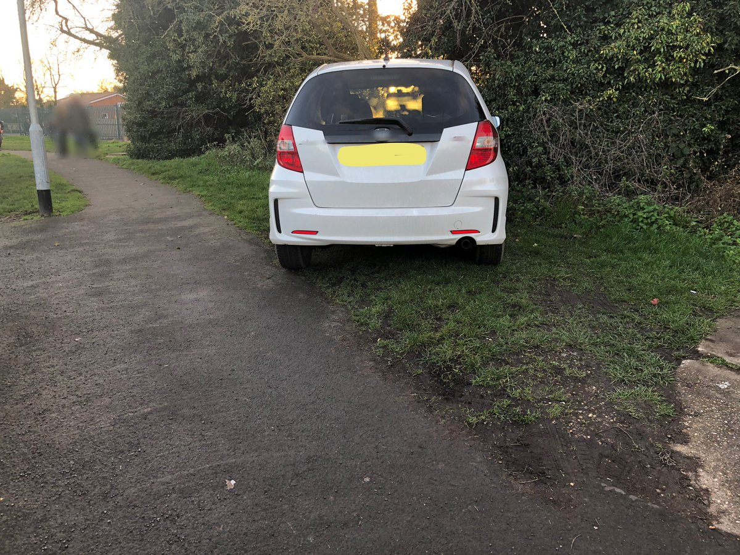.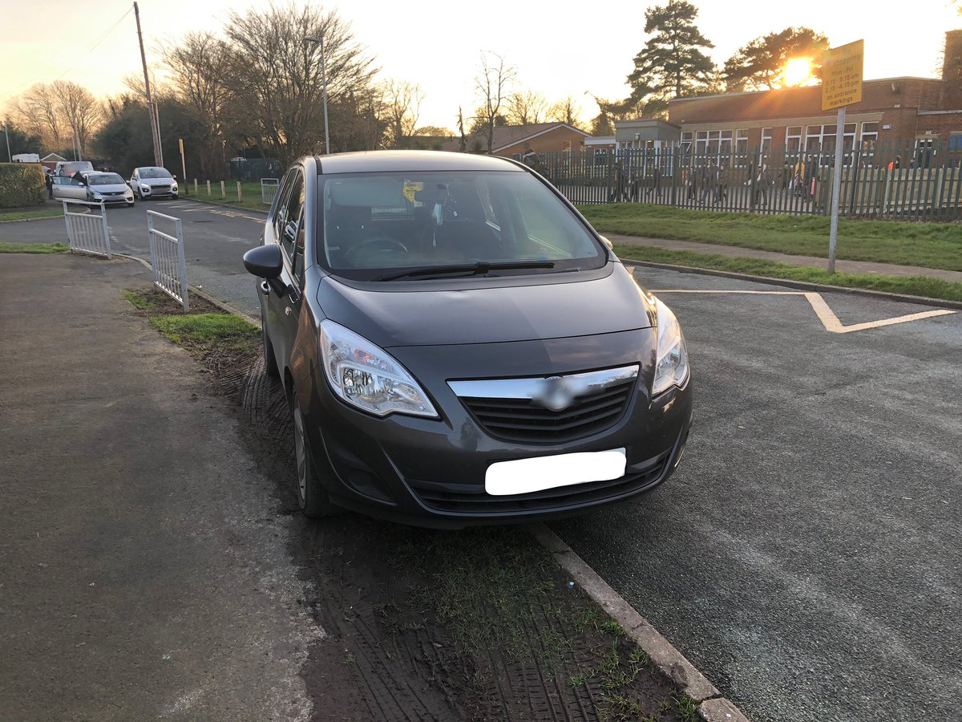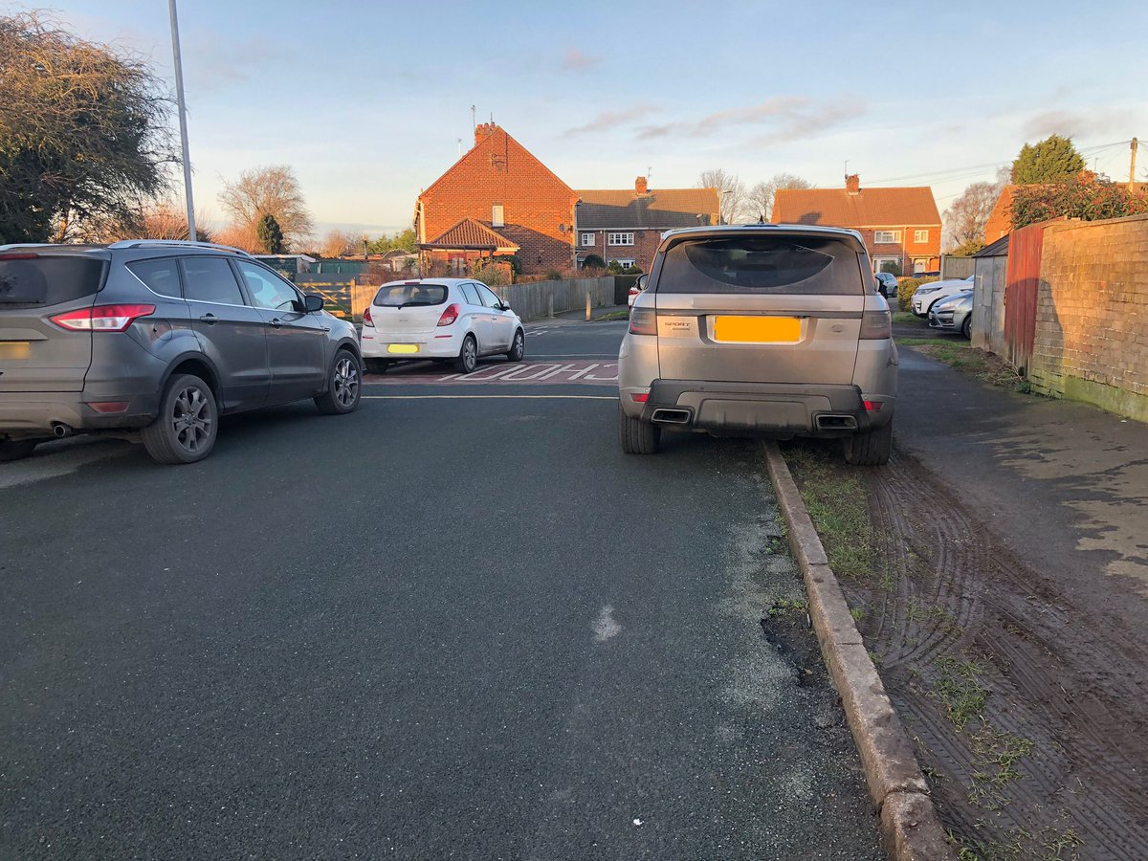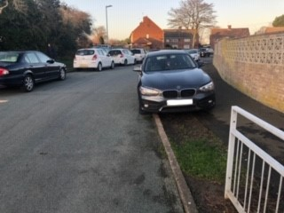

PARENTS are being urged to ensure they are not obstructing roads or pavements around schools when they park.

The plea comes from Police Community Support Officer Darren Bainton, whose area includes Mid Holderness, following a rise in obstructive parking.

He said there had been an increase in reports of vehicles double parking, blocking the pavements and abandoning cars on the yellow zig-zag lines.

“None of the above is acceptable, and if you are found to be in contravention of any of these you could be handed a fixed penalty notice of £30,” he said.

Residents told their neighbourhood policing team that they felt parking outside Bilton primary school was dangerous, prompting a response from the community forum.

In a Facebook post on Friday, officers said: "This has been adopted by the police as a neighbourhood priority.

“We are very aware that parking outside our local schools has always been an issue raised by residents, and that the areas around our schools are perhaps not best suited to a high volume of cars to park.

“However we need your support urgently to ensure you are not obstructing roads or pavements around the schools.

“We are also looking to start our ‘junior safety officers’ project with the local primary schools.

“The junior officers will help us educate people who are parking dangerously and inappropriately.

Parking on the pavement may not sound like a major problem, but for parents with buggies, people using wheelchairs, people with visual impairments or older people who need support to walk, pavements blocked by parked cars can mean there is no way through without being forced to risk walking in the road which can seriously inconvenience the pedestrian and their safety.

Waiting restrictions indicated by yellow lines apply to the carriageway, pavement and verge/zigzags and are there for a purpose: Because of their size, children cannot see if the road is clear from behind parked cars. Drivers cannot see small children hidden by parked cars.

Over the week several checks of the location had been made by the Neighbourhood Police Officer and those drivers who had been found to be parking in a careless or dangerous manner have been spoken to and provided a letter containing information on safe parking and locations.

We have full support from Bilton Primary Staff and in cooperation with the Bilton Village Hall committee who have provided the use of their car park which is close to the school and has no main roads to cross. If you have to travel by car, Please use the Park’n’Stride at the Bilton Village Hall, Main Street, Bilton HU114AA it’s only a 300metre walk away and it saves traffic having to manoeuvre around the estate only to find there are no safe parking places near to the school.

We ask for all motorists not to park on the pavements; stop, park or set down and pick up passengers on School markings. We will be patrolling the area and any vehicles found causing an obstruction on the pavement will be issued with a fixed penalty ticket for that offence.

We seek parents full cooperation in this matter, working together to keep our neighbourhood safe for everyone.

“for more information follow us on social media where we are able to speak directly to you as our community about incidents and crimes we are finding in the area.

“Please like our Facebook page ‘Humberside Police - East Riding of Yorkshire South or follow our Twitter accounts ‘@PCSODarrenB @Humberbeat ERYS’.

- Meet your officers

PCSO Darren Bainton will be at the following locations to discuss community issues and offer crime prevention advice:

- 5th February 6:30pm to 7:30pm Bilton Church Hall, Bilton HU11 4AA
- 10th February 7pm Aldbrough Parish Council at the Primary School, Headlands Road, Aldbrough HU11 4RR
- 27th February 7pm Burstwick Primary School, Main Street, Burstwick

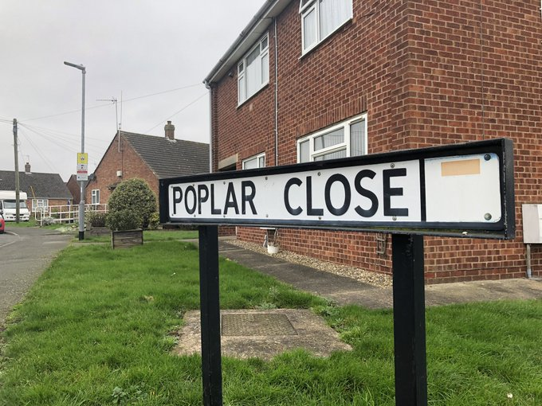

A meeting with residents of Poplar Close, Skirlaugh was recently held to discuss local issues & set priorities along with Councillor Corden from Skirlaugh Parish Council. Three residents have volunteered to assist set up a Community Speed Watch scheme in the village following complaints of speeding vehicles on Church Lane and Benningholme Lane.
5. News and Appeals

Please visit our website www.humberside.police.uk for the latest news & appeals

FACEBOOK users did you know? You can find out more about the work of your local officers and teams by liking their facebook accounts:

please visit Humberside Police – East Riding of Yorkshire South https://www.facebook.com/HumberbeatERYS

Twitter users can keep up to date with events, alerts and traffic news within Mid Holderness by following the community team @HumberbeatERYS and @PCSODarrenB. Your Neighbourhood Police Officer, Darren Bainton is celebrating his fifth anniversary on using TWITTER to send out news, appeals and advice to his followers.

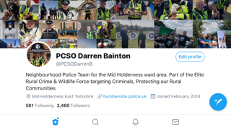

6. My Community Alert – sign up for free

“My Community Alert” is a, free messaging system operated by Humberside Police and Humberside Fire & Rescue Service, giving you live information about incidents happening in your area.

Choose how you receive messages, by either phone or email, how often you want to hear from us and about the issues that matter to you.

When something happens that you’ve told us you want to hear about, your local officer will send you the details, whether that’s notice of a road closure due to a collision or a burglar who has been caught in a nearby garden.
Subscribe to My Community Alert to be the first to know about issues that might affect you or your family.


Did you know you have a 'right to ask' police if you're concerned that your partner may pose a risk to you? Find out more about Clare's Law and how to apply by visiting www.humberside.police.uk

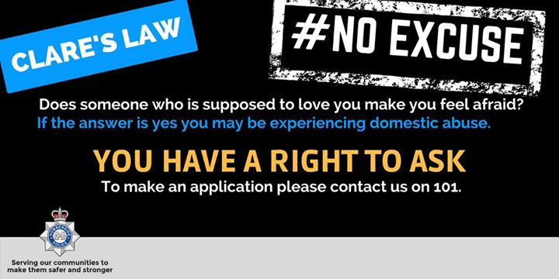

If you get a call from someone claiming to be your bank or the police and they ask you to transfer money to another account, hang up, it’s not your bank or the police. Visit @actionfrauduk website for more info https://www.actionfraud.police.uk/a-z-of-fraud/courier-fraud

